
Politecnico di Milano – V Facoltà di Ingegneria

075274 e 070644 - Sistemi distribuiti (con laboratorio)
Prof. G. Cugola

Appello del 23 Giugno 2010
Rules:
- You are not allowed to use books, notes, or other material.
- You can answer in Italian or English.
- Total time for the test: 2 hours.

- Implement in Java a ThreadPool. At creation time a number of threads, decided through a parameter passed to the constructor, is instantiated and they are used to execute jobs passed to the ThreadPool thorough the following method:
void run(Runnable job)
It executes the job using one of the threads instantiated at the beginning (as soon as one of them is free). The run method should return immediately either if a thread is available or if it is not and the job has to wait for one to finish and become free.

- Describe “attribute based naming systems” and explain how an attribute based system can be organized in a structured way to ease distributed resolution.

- Describe what we mean by “cut” and “consistent cut” and describe an algorithm to capture consistent cuts in a distributed system.

- Calculates the recovery line for the two diagrams below using the rollback-dependency graph for the first one, the checkpoint dependency graph for the second one.

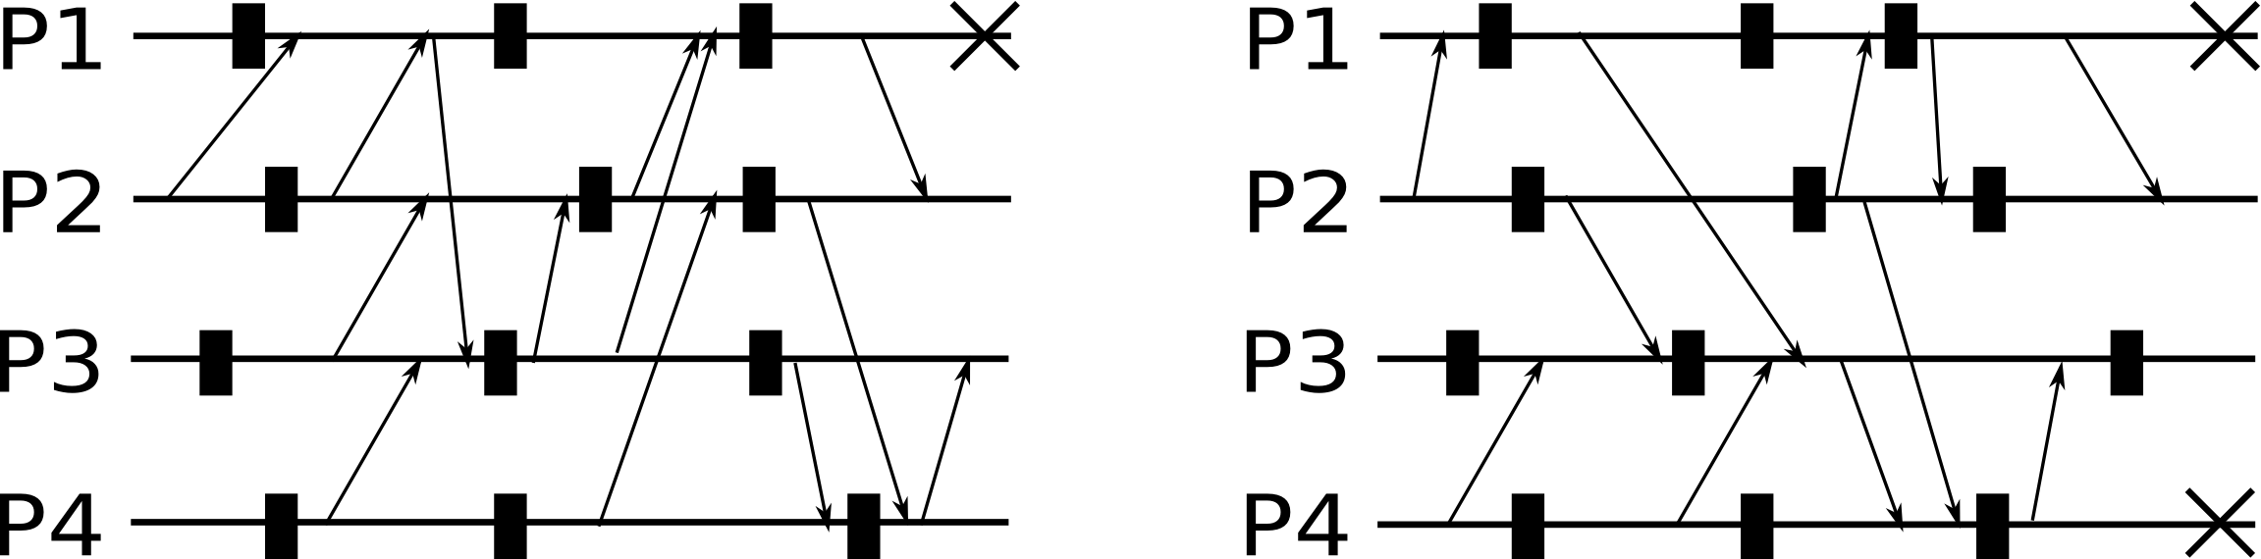

- Describe the three phase commit protocol in details.

- Consider the following situation: a Client and two Servers communicate with each other using a shared Store that contains five variables, as shown in Figure.

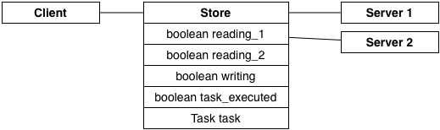

The client generates a new task, waits while the servers execute it, and then generates another task. The code for the client and the servers is shown below.

Client
while (true) {
writing = true;
if (! reading_1 && ! reading_2 && task_executed) {
task = new Task();
task_executed = false;
}
writing = false;
}

Server n
while (true) {
reading_n = true;
if (! writing && ! task_executed) {
task.execute();
task_executed = true;
}
reading_n = false;
}

Assume for simplicity that each line of code is executed as an atomic operation, and that a sequential consistency model is adopted.

- Does the code guarantee that each task is executed at least once?
- Does the code guarantee that each task is executed exactly once?
- How do your answers change if a FIFO consistency model is adopted?

Motivate your answers.

- Consider the following P2P architectures for filesharing applications:

- Centralized Database (e.g. Napster)
- Query Flooding (e.g. Gnutella)
- Distributed Hash Table (e.g. Chord)

Describe and compare them focusing on the algorithms they adopt for joining the network, and for publishing, serching, and fetching files.

